Hi guys, in this article I want to shared overview about API Management in SAP Integration Suite. Before go to example, we take a look about some concept in API Management
1.Concept
- API Provider
The API Provider is used to abstract the connection to the backend / target system
The API Provider will connect to backend system. Ex connect to SAP to collect ODATA service collection. In fact, API Provider will connect to developer system where will create many data service
- API Proxy
API Proxy is real API which contain logic to get data from DATA service layer. In this API Proxy we can apply Policy Template for security, transform incoming message or look for content injections.
- API Product
API Product will bundles one or more API Proxies before they are exposed in the API Developer Portal so they can be consumed by a developer.
2. Demo API management
In this section, we will discuss about how to create API Provider, API Proxy and expose many API proxies by API Product.
We will ref to ODATA service collection which expose at SAP Gateway Demo ES5.
If you do not have account at SAP demo ES5, kindly click here to registry for free.
Step 1 : Create API Provider connect to backend SAP Gateway Demo ES5
- Go to SAP BTP Cockpit
- Go to sub account
- Go to Instances and Services
- Go to Integration Suite Application
- Go to API Management
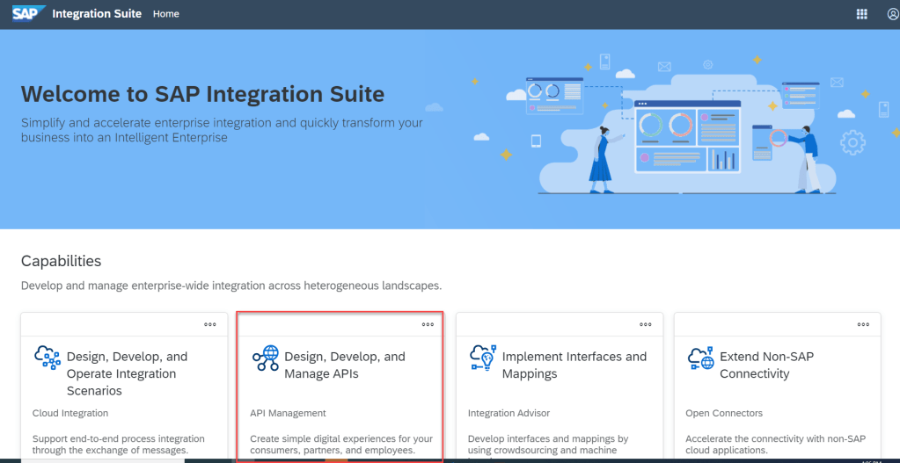
- Go to Configure on left menu
- Tab API Providers
- Click Create
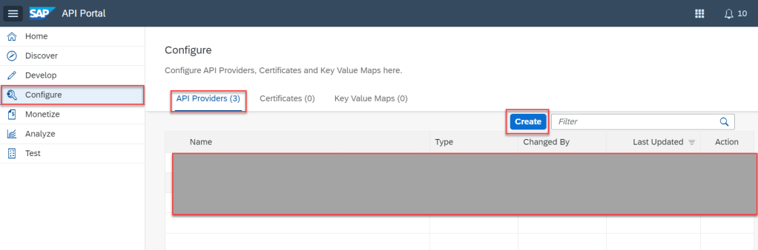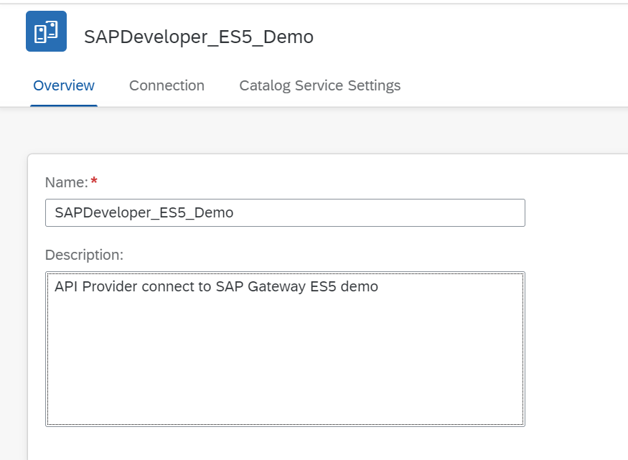
Type | Internet
Host | sapes5.sapdevcenter.com
Port | 443
SSL | checked
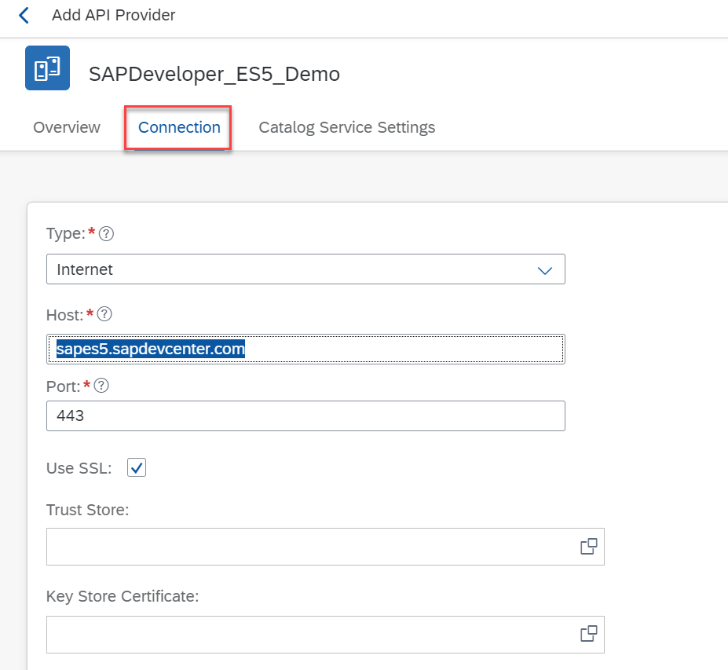
Path Prefix | /sap/opu/odata//IWFND
Service Collection URL | /CATALOGSERVICE/ServiceCollection
Authentication type | Basic
Username | account login ES5
Password | password ES5
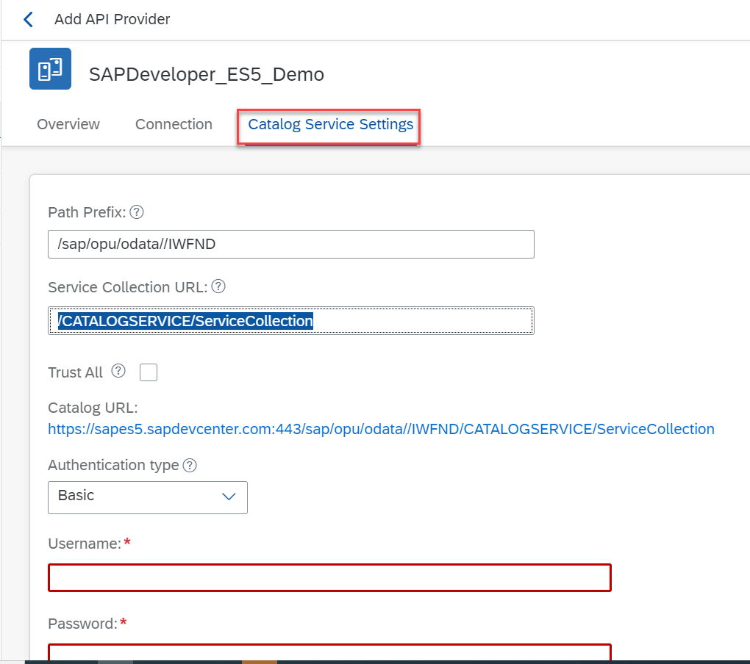
- Save
- Test Connection
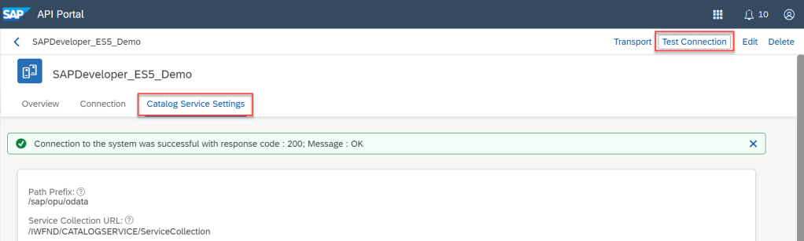
Step 2 : Create API Proxy
- Go to API Portal
- Menu Develop at left pane
- Tab APIs
- Click Create
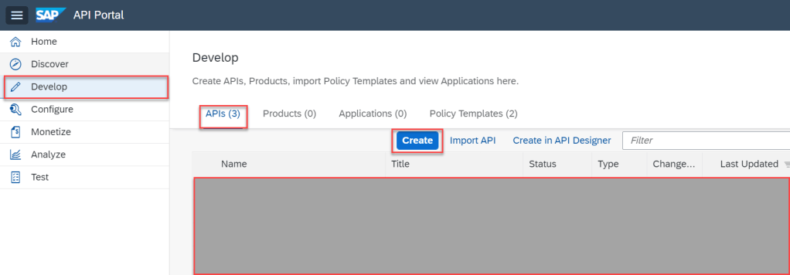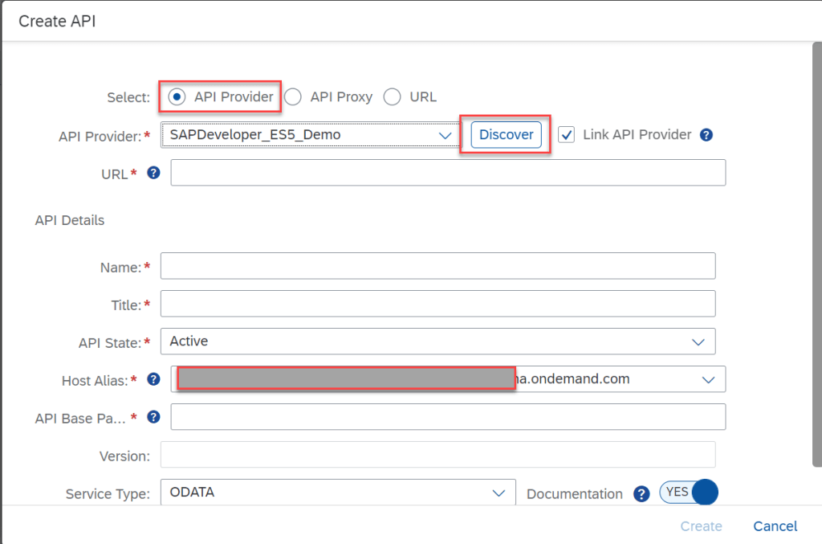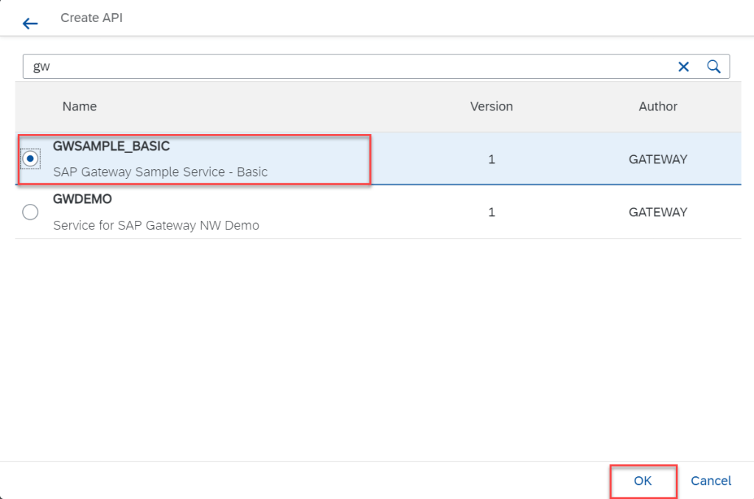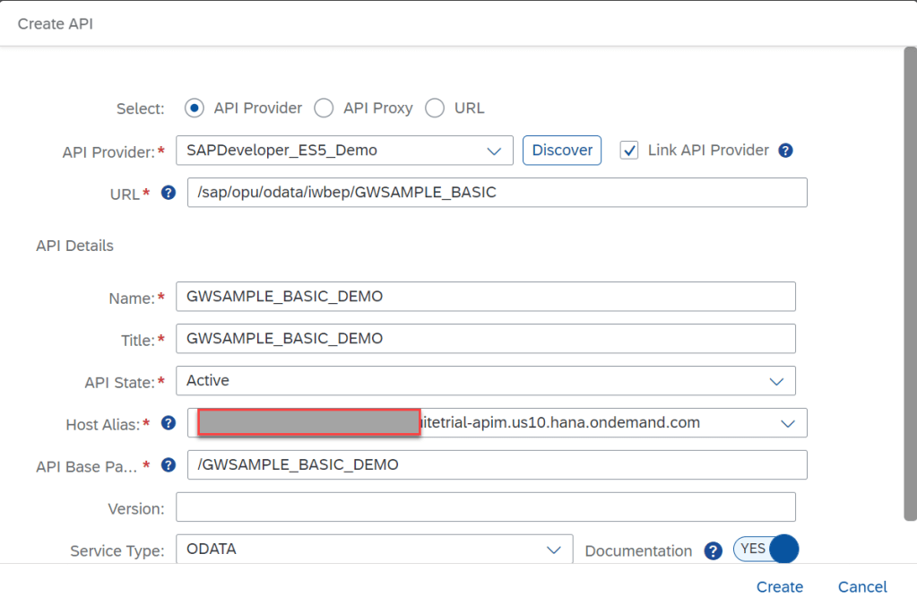
- Tab Overview
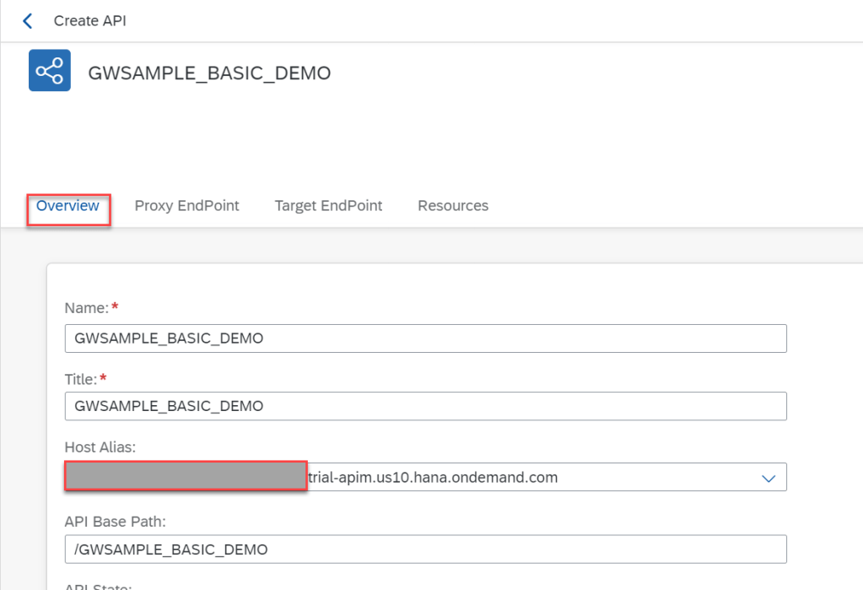
- Tab Target Endpoint, we see that, this API Proxy use API Provider which connect to backend of SAP gateway Demo ES5 in step 1
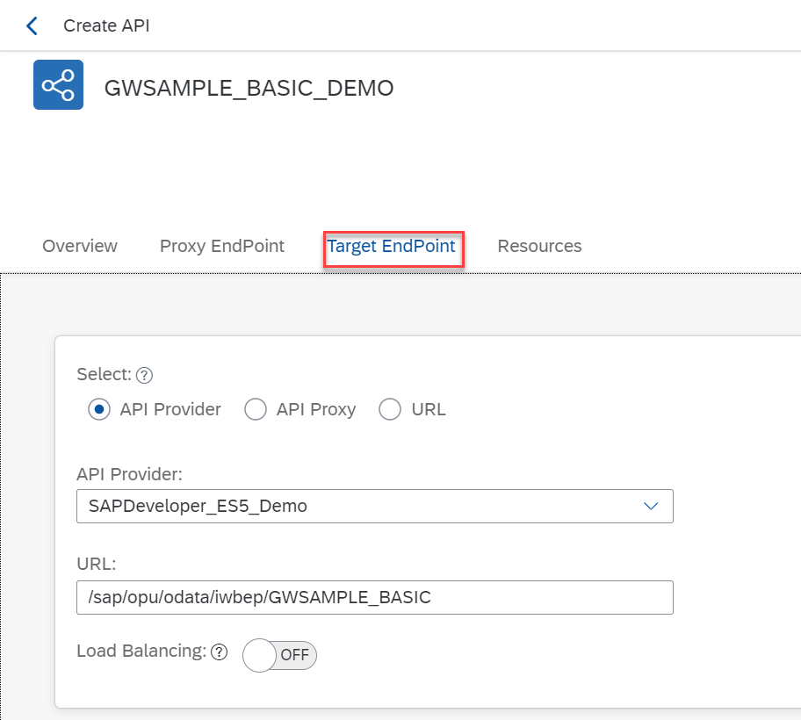
- Tab Resources, we see a list of data service display in Swagger. We can run test every data service
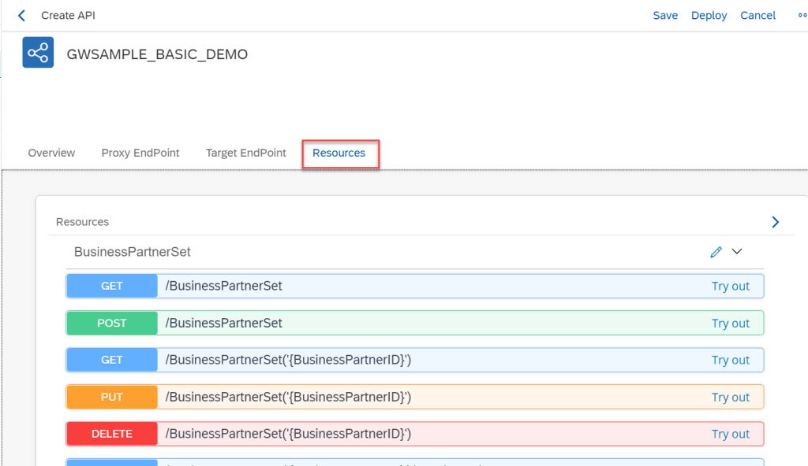
- Save
- Deploy API Proxy
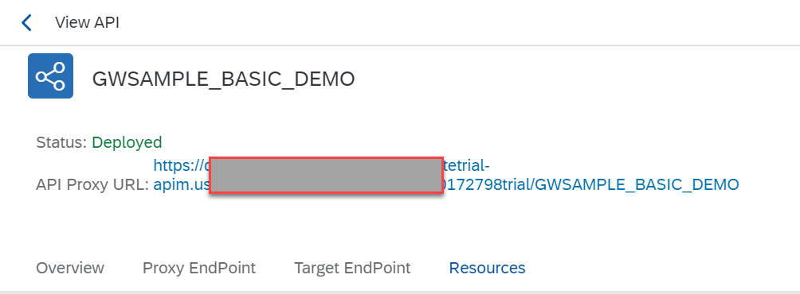
For demo API Product can including one or more API Proxy, We will create one more API Proxy with the same way above.
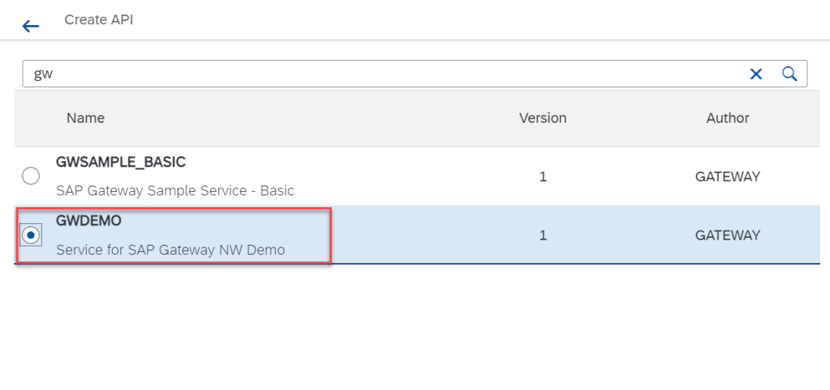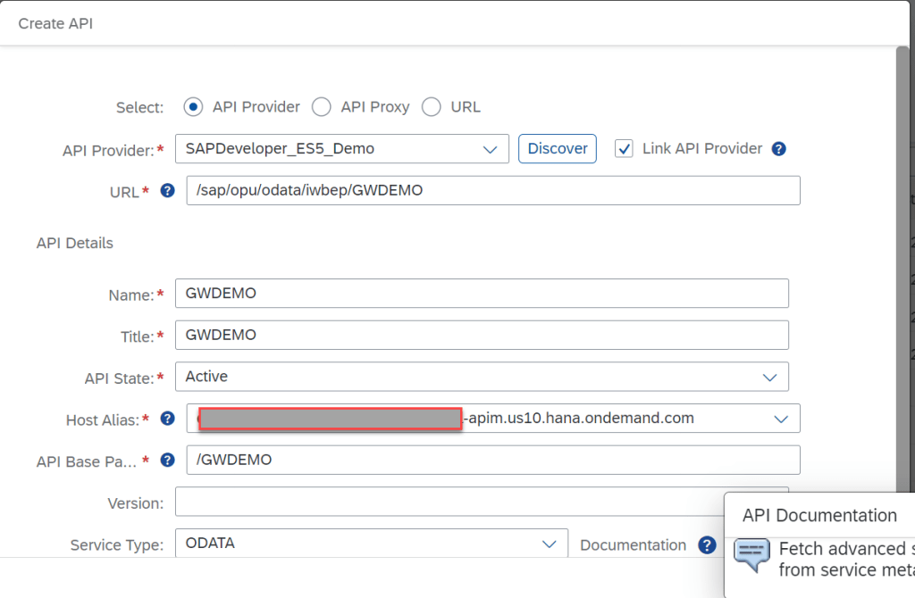
So, current we have two API Proxy
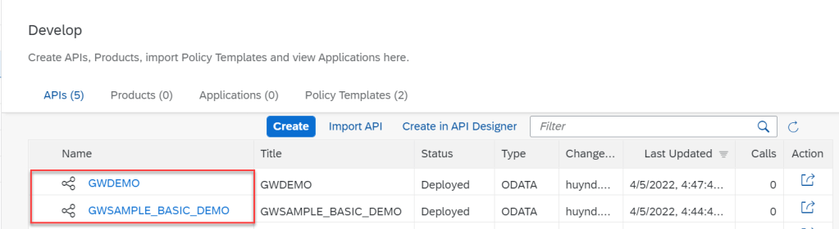
Next, we will create API Product bundles two API proxies.
Step 3 Create API Product
- Go to API Portal
- Go to Develop at left pane
- Tab Products
- Click Create
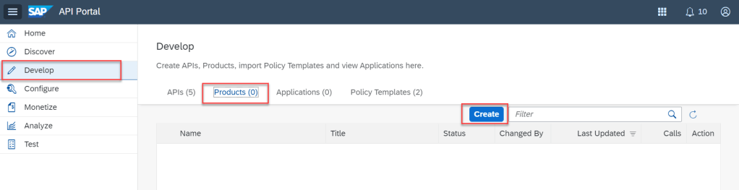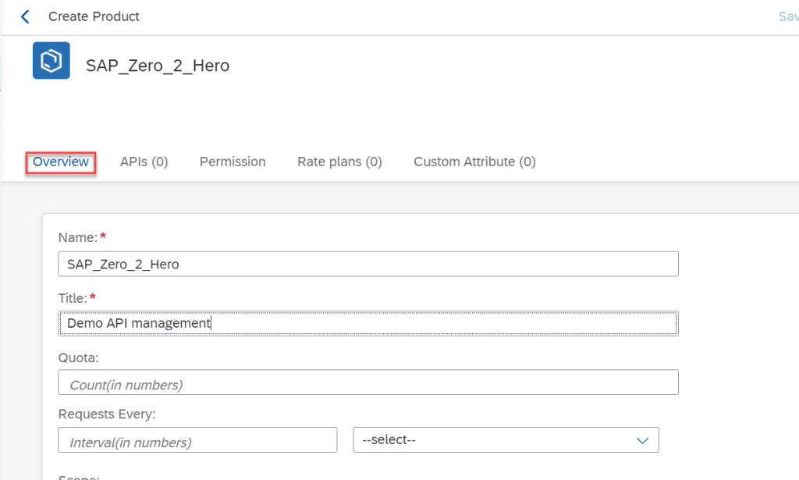
- Tab APIs. Add two API Proxies in Step 2
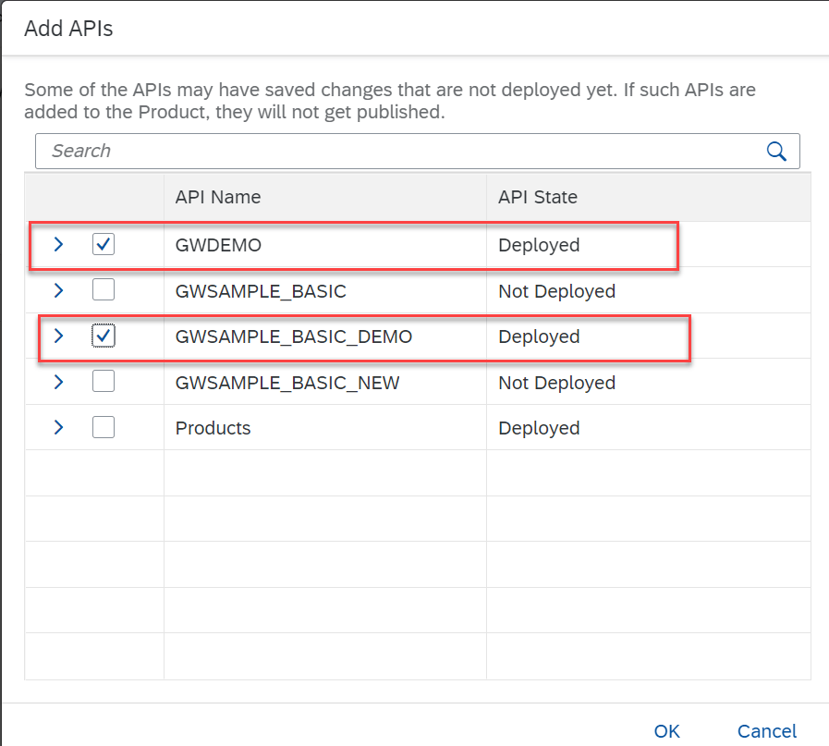
NOTE : You can choose every API which including in API Proxy to expose
- Publish API Product
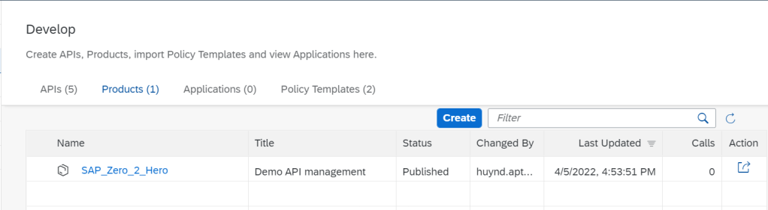
Step 5 Exploring API Business Hub
After create API Product, we need monitoring, run test API Proxies in API Product. How can we do? API Management in Integration Suite Application support one thing called is API Management Business Hub. When we go to capacities of API Management, we see one endpoint for this
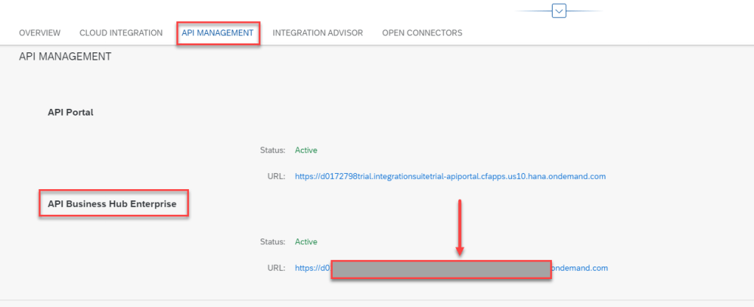
Click on this endpoint, we will go to API Business Hub Enterprise and API product will in there
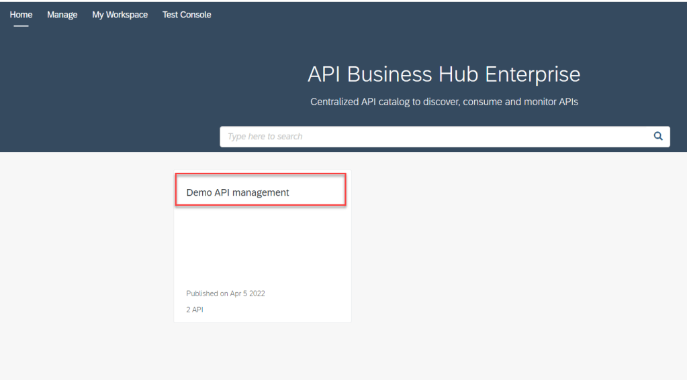
Click on API Product, we will go to API Proxies.
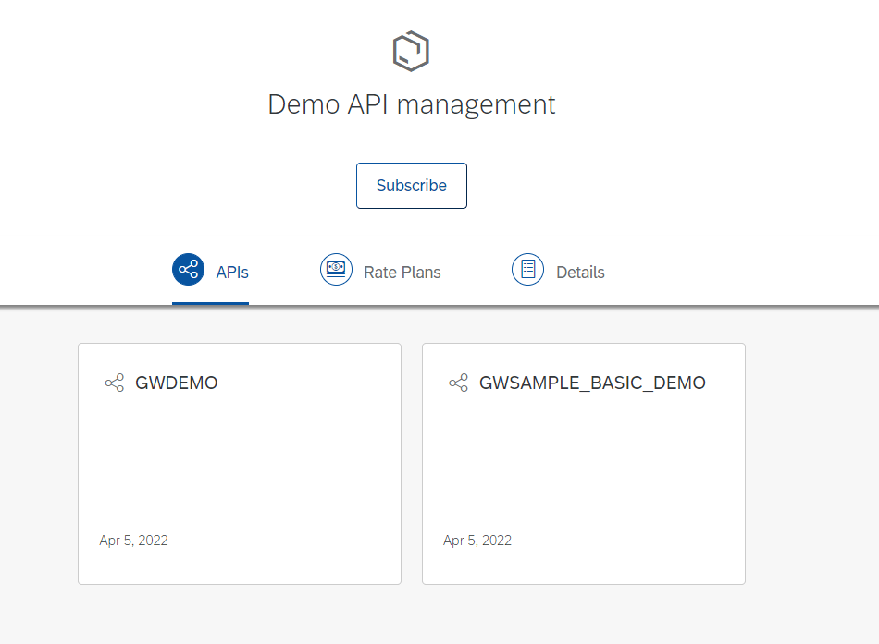
Click on every API, we will go to detail of that API.
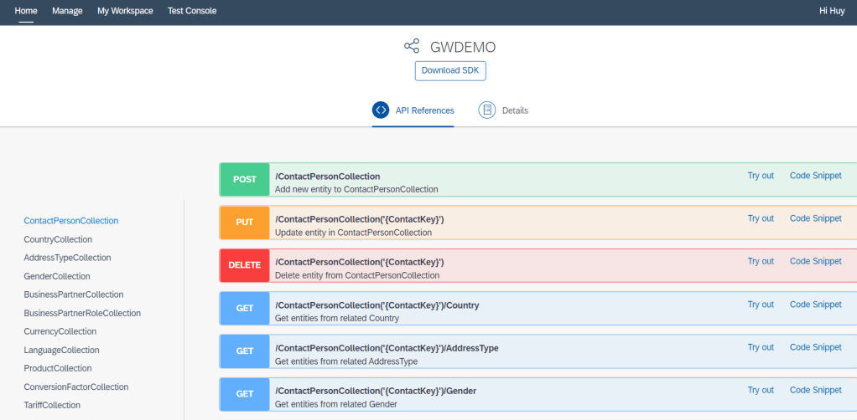
With API Business Hub, we can manage all our API in one hub.
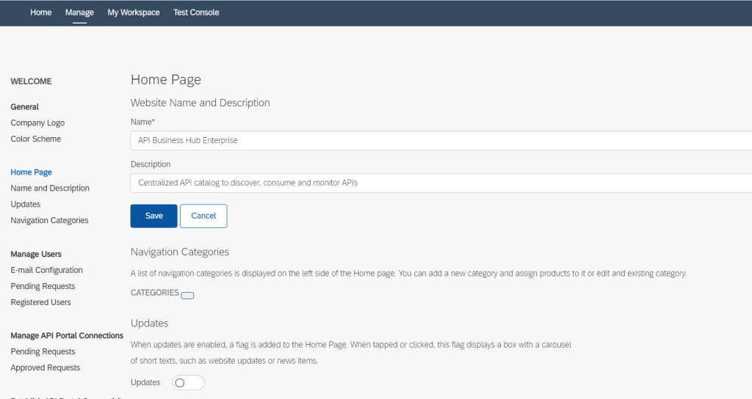
Summary
In this article, I shared overview API Management of SAP Integration Suite. With this API Management, we can create one or more API proxy and add into API Product for manage. I also talk about API Business Hub after create API product to manage all our API which expose to customer. Thanks for your reading and appreciate your comment if have any idea. If have any question, kindly leave your comment on below this.

